**Machine Learning**

Logistic Regression

Why??

We need a way to use machine learning in classifying data, so the easiest way is by using a binary classification which is described by logistic regression.

Which function do we use in logistic regression?

We use sigmoid function, but why not linear as the previous one?

Ok, when we use linear regression line in a classification type it might be okay, but it has a chance to be one of the worst decisions you might choose.

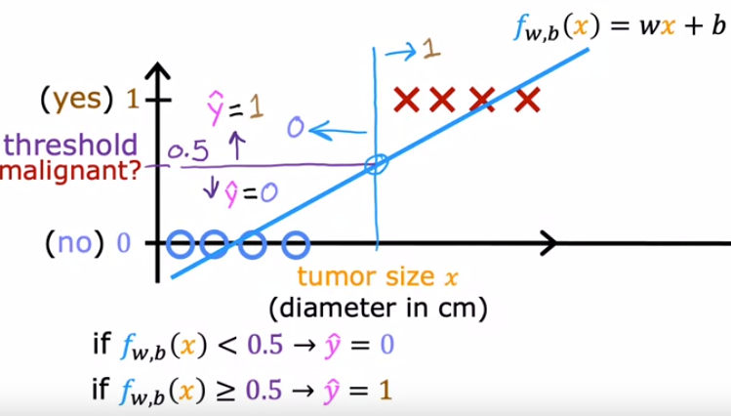it’s okay for this data-set

but if we had unfair distribution of the data-set the model would be misleading like the following example

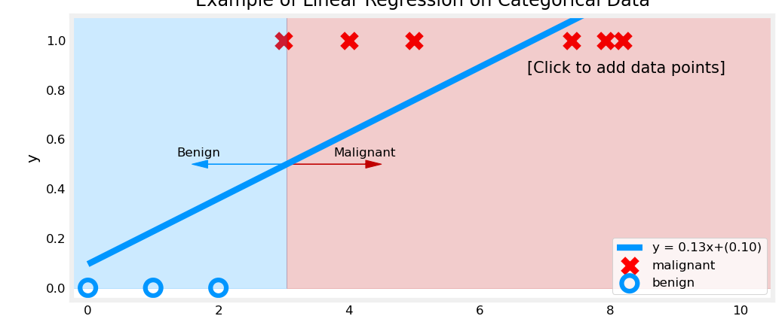

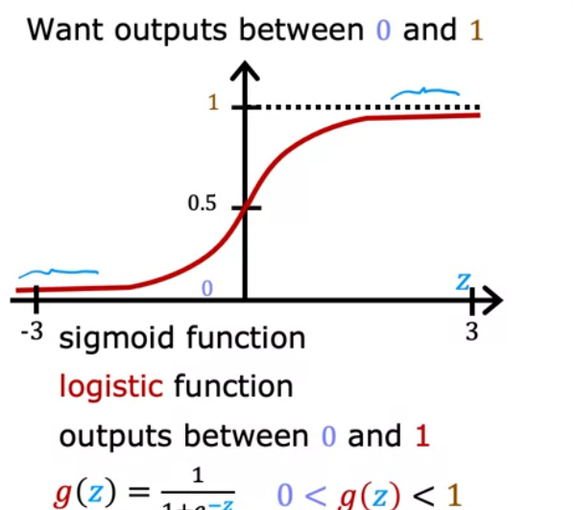So, we need a function

that isn’t affected by that which is

sigmoid function.

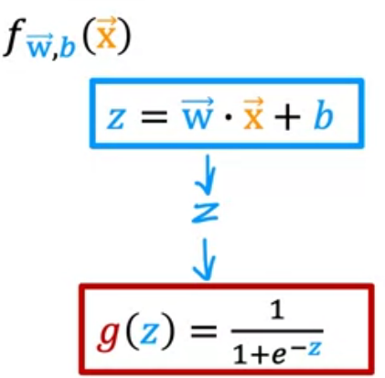

___

Decision boundary

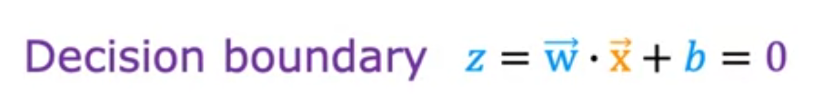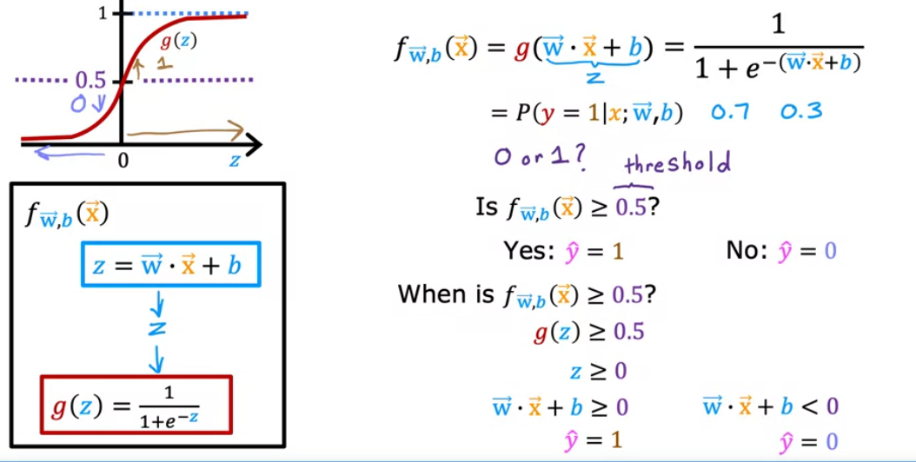



___

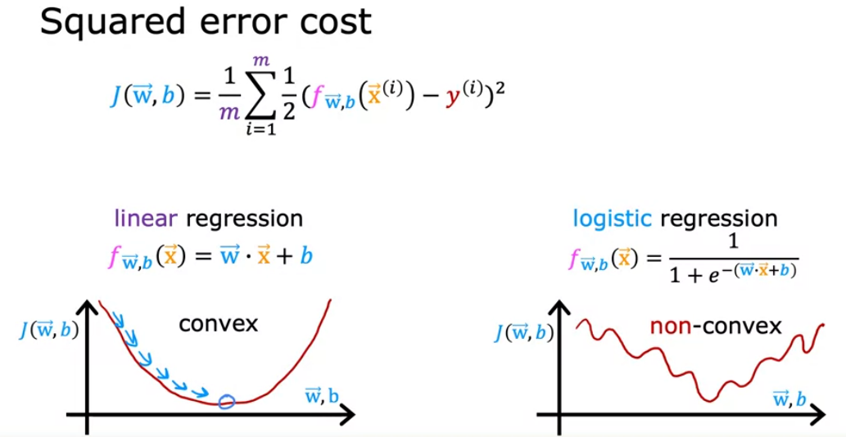Cost function

When we use SME function to calculate the cost for logistic regression it appears that it isn’t convex



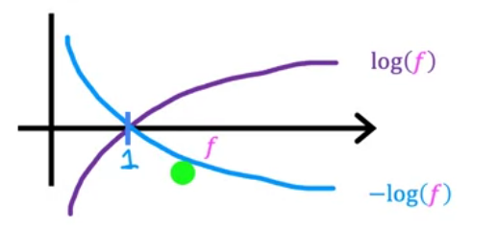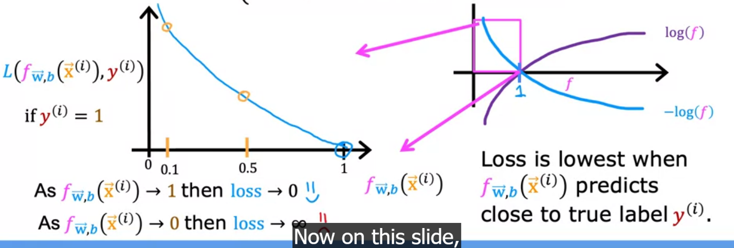

Simpler way to write cost function



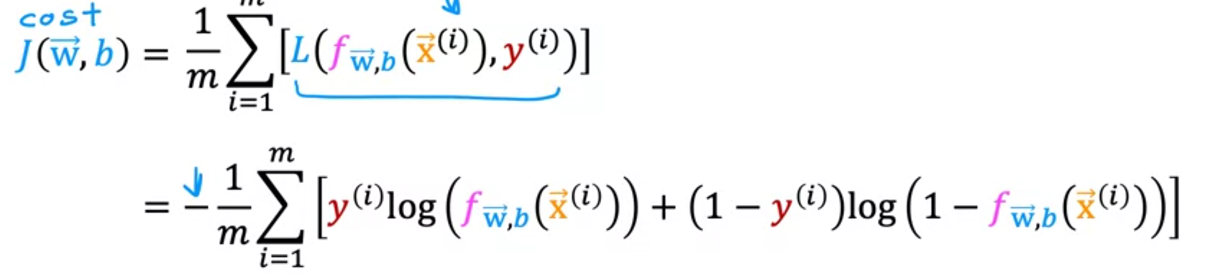

___

Gradient Descent

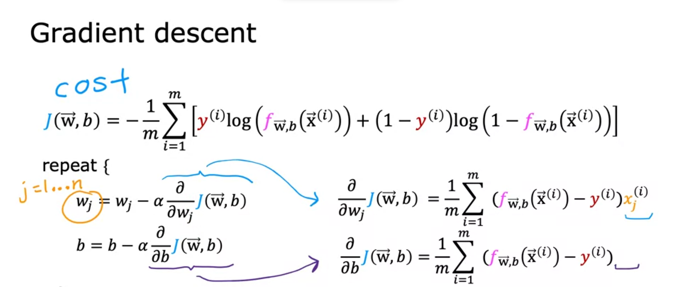

___

Problem of over-fitting (high variance) and under-fitting (high bias)

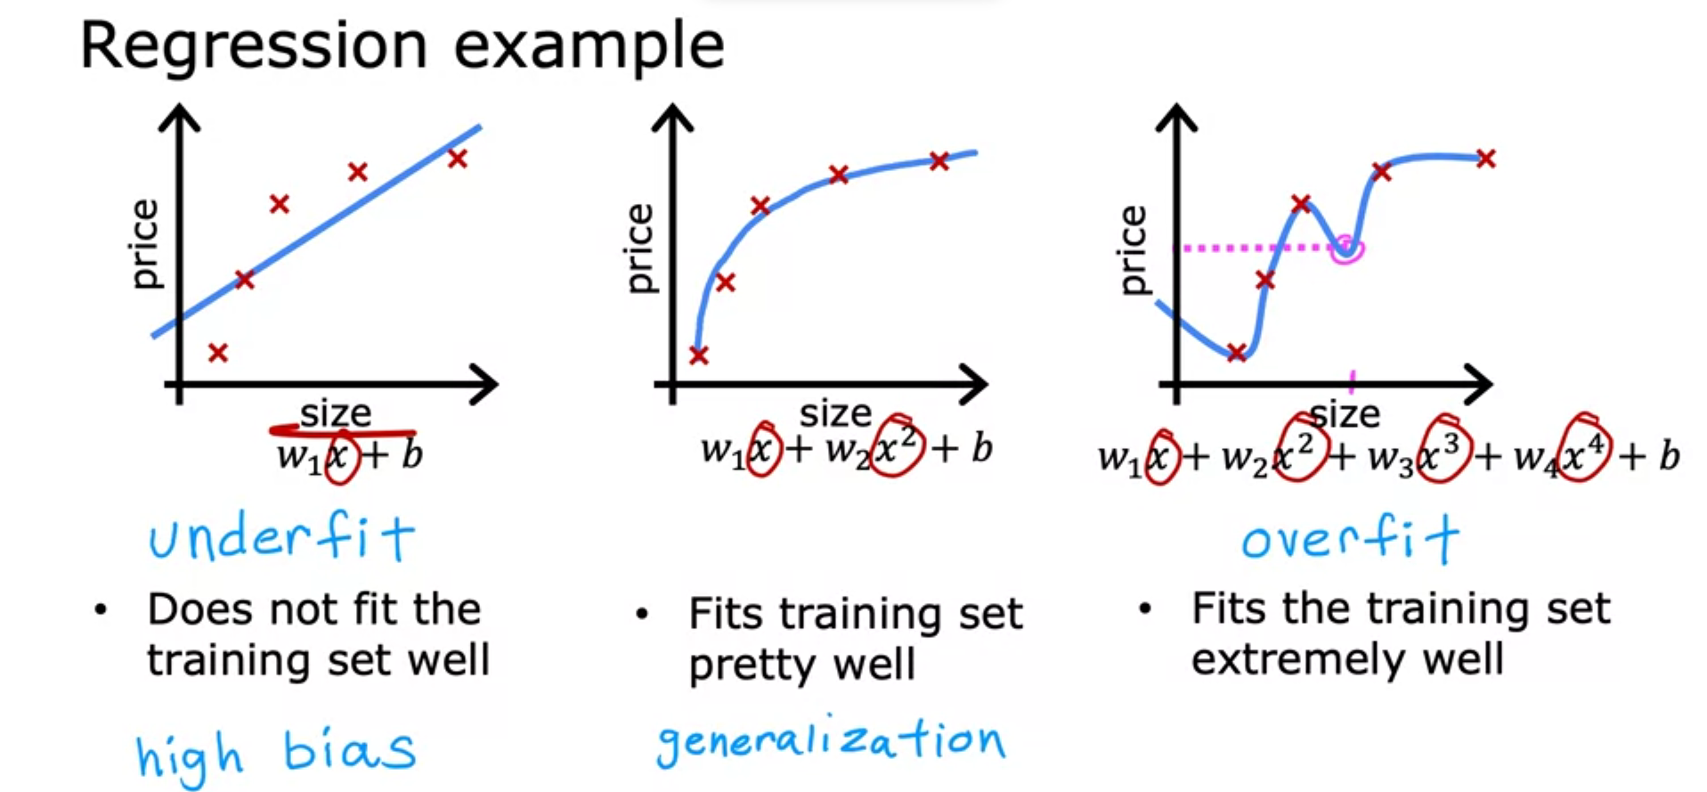

___

Regularization to reduce overfitting

To reduce overfitting there is several ways to do





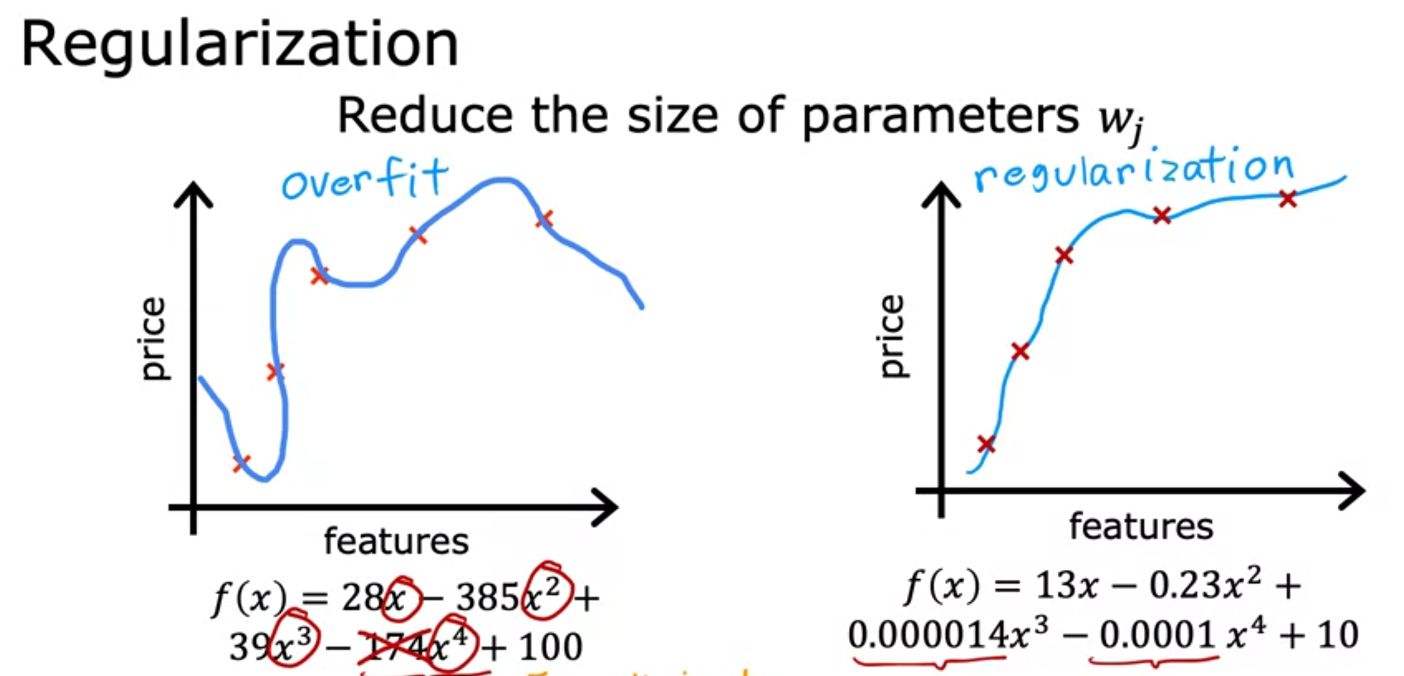

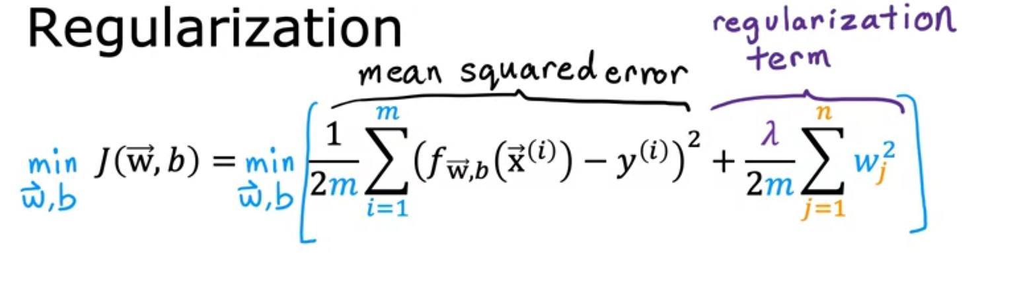

For linear regression

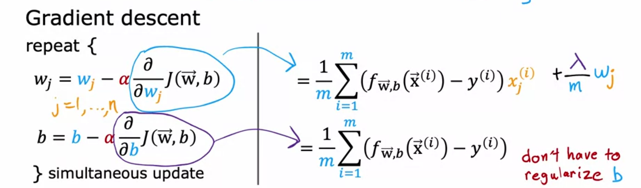

For logistic regression

